*****************************************************************************
Other than the national championship, North America’s longest recurring Scrabble tournament.
The 40th anniversary edition of
SWILLLNS 2024
Southwest International LLL-Note Special
In the spirit of collaboration, we are pleased to announce this event is co-sanctioned and will be rated by both NASPA and WGPO. The event will also serve as a fundraiser for two worthy causes:
1. NASPA: Foundation for Youth Literacy Program, 2. WGPO: Philly After School Scrabble Program.
Enjoy our view of over 2500 square miles of the Rio Grande Valley.
In Corrales, New Mexico, about 35 minutes from the Albuquerque Airport
Limited to first 24 registrants NWL23 18-game event Directed by Cornelia Guest
**************************************************************************************
WHEN: GAMES on SATURDAY & SUNDAY, JUNE 8th and 9th, 2024
Format if 24 players: Day 1: 11-game Round Robin. Day 2: 4-game RR + 3 playoff rounds.
Extend your stay: consider a visit to Sandia Peak Aerial Tramway (https://sandiapeak.com/ for reservations), Santa Fe (55 minutes north), or White Sands National Park, https://www.nps.gov/whsa/planyourvisit/index.htm (see if Jackson Smylie and Mack Meller’s “SWILLLNS” lettering is still intact there).
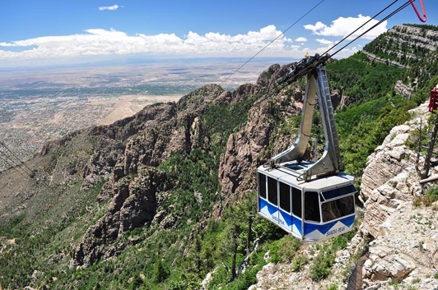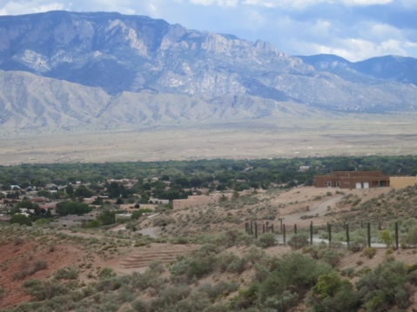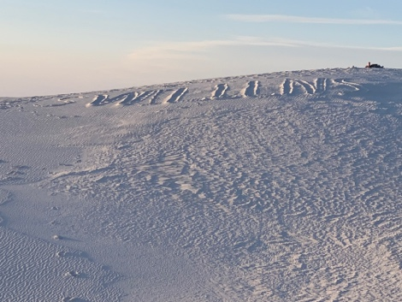
Jun 8 Sat: 9:00 Sign-in, pairings, announcements, etc.
9:30 Round 1-3
12:30 Lunch provided
1:00 Rounds 4-8
6:00 Dinner provided
7:00 Rounds 9-11
Jun 9 Sun: 9:00 Rounds 12-15
1:00 Lunch provided
1:30 Rounds 16-18 (Gibsonization, if needed.)
4:30 Awards ceremony. Prizes: 1st - $1,040 (prizes based on 24 paid registrants)
2nd - $540, 3rd - $440, 4th - $340. High finishers <1700 rating: 1st - $240, 2nd - $140.
100% of registration fees returned in prizes and food. There are no participation fees.
5:30 Optional dinner at The Range Café in Bernalillo (20 minutes north of tourney)

FEE: Three L-Notes ($150). We are guaranteeing a minimum of $500 to be raised for NASPA’s cause (Foundation for Youth Literacy Program) and at least $500 for WGPO’s cause (Philly After School Scrabble Program). Donation to either cause is optional. IF you do wish to donate, please add that amount to your registration fee, and please note to which cause(s) you are donating: “NASPA” or “WGPO,” or “Both.” Example: If your check is for “$190” with “Both” noted, $20 will be donated to both causes. To register, send check or money order payable to Mike Baron, 1496 Sagebrush Drive, Corrales, NM 87048. Alternates (registrants #25 and up) will be contacted in the event one or more of the first 24 needs to cancel. Please include your email address and cell phone number when you register. FIELD WILL BE LIMITED TO THE FIRST 24 WHO PRE-REGISTER, based on postmark. If you don’t get to play, your fee will be fully refunded. Historically, between January and June, 5-8 registrants cancel, so many Alternates move into Player status.

You must be a member of both NASPA and WGPO. For NASPA: http://scrabbleplayers.org/cgi-bin/join.pl (trial membership $15 available). WGPO membership is free: sign up at https://wordgameplayers.org/signup/ .
COVID-related precautions As of November 2023, our guideline for June 2024 will be: If you have COVID-19 symptoms, you must test yourself and have a negative result before arriving.

WHERE: Pamina Deutsch and Mike Baron’s home: 1496 Sagebrush Drive, Corrales, NM 87048, 21 miles northwest of Albuquerque’s airport (35 minutes). In the photo below, it’s the brown home on the left behind the turquoise gates. Please note: No smoking on property.

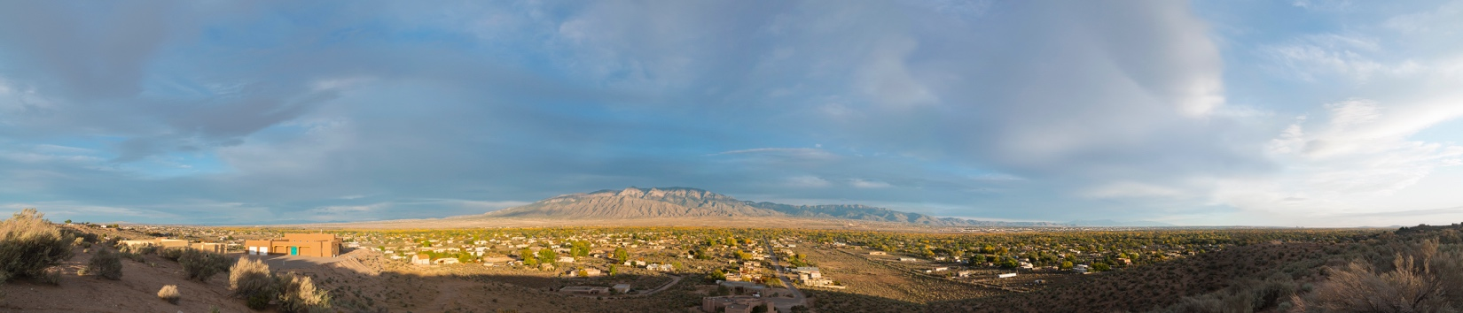

WHY: To enjoy the camaraderie, catch a phenomenal view of the Rocky Mountains, eat great food, and gear up for Word Cup and SPC. Consider extending your weekend to hike one of the four mountain ranges you can see from the tourney site or soak in natural hot springs, visit Santa Fe (50 minutes north of Corrales), see Tent Rocks on the way to Santa Fe, ride the US’s longest aerial tram ride (25 minutes east of Corrales), or see a variety of Indian pueblos (including Acoma-Sky City, the longest continuously occupied residence in the US, about an hour west). Questions? Email us at: michael@michaelbaronphd.com or pdeutsch@unm.edu.

TRANSPORTATION
21 miles (about 35 minutes) from Albuquerque Airport to tourney site. Taxis one-way can run about $40-$60. There’s always Uber or Lyft. However, as in years past, registrants will be updated via email on who needs and who can provide rides from/to the airport.

LODGING: You’re on your own, but you should be able to find some airbnbs in Corrales and hotels in adjoining Rio Rancho for under $100/night. Here is some contact info. If you wish to explore other area lodging, use zip code 87048 for Corrales, or 87124 for Rio Rancho. Our updates will also include “seeking roommates.”

Corrales Bed and Breakfasts book now before June wedding parties! (from 2 to 4 miles away).
airbnb throughout Corrales starting from $55/night www.airbnb.com/s/corrales
Sandhill Crane 389 Camino Hermosa 505-898-2445 innkeeper@sandhillcranebandb.com (Judith) www.sandhillcranebandb.com
Chocolate Turtle 1098 W. Meadowlark Ln. 505-898-1800 innkeeper@choclateturtlebb.com (Keith)
www.chocolateturtlebb.com
Corazon de Corrales 89 Senescu Ct. 505-891-4408 corazondecorrales@gmail.com (Charlene)
www.corazondecorralesbb.com
Morning Star B&B 384 Chaparral 505-322-2177 innkeeper@morningstarcorrales.com (John&Carol)
https://www.morningstarcorrales.com

Hotels Here is a sample of the places in the area.
ABQ = Albuquerque, about 25 minutes drive to house.
RR = Rio Rancho, about 15 minutes drive to house.

- Staybridge Suites, ABQ North 5817 Signal Ave NE, ABQ 505-266-7829
- Extended Stay Deluxe 2221 Rio Rancho Blvd SE, RR 505-892-7900
- Comfort Inn 4801 High Resort Blvd., RR 505-892-5998
- Motel 6 (ABQ North) 8510 Pan American Fwy, ABQ 505-821-1472

