ANNOUNCING
SCRABBLE® TOURNAMENT
AT HISTORIC FT. MYER!
SATURDAY, APRIL 29, 1 PM
Myer Community Center Ballroom (Building 405)
228 McNair Rd. Ft. Myer, VA 22211

7-rounds, fully rated tournament. Entry fee $50. Dinner after round 5, included in entry fee. TWL and Collins (5-pt. penalty) will be offered.

5-round newcomers’ division open to all military personnel, dependents, retirees, and DoD civilians who have never played in a NASPA tournament before. Free entry.

You must have a valid ID to gain access to Ft. Myer. If you do not hold a military ID, please allow extra time to have your vehicle searched at the gate. No weapons are allowed to be brought onto post.

Sponsored by:
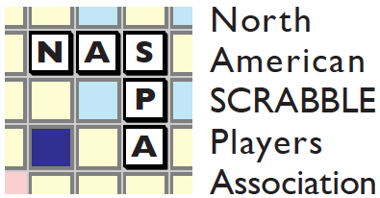
Questions? email Martin Gold: fortmyerscrabble@gmail.com

Registration form for Ft. Myer Tournament 4/29/2017

Circle one:

TWL: $50 CSW: $50 Newcomers’ division: $0

TOTAL ENCLOSED:

Name: ______________________________________NASPA #________

Address: ____________________________________________________

Phone/cell: __________________________________________________

Email: _______________________________________________

Make check payable to Martin Gold and mail to the following address:

Martin Gold
4029 7th St. S.
Arlington, VA 22204

PayPal entries accepted. Send to ytram79@gmail.com

Membership in NASPA required for all events except Newcomers Tournament. Director may ask players to play up to balance divisions and may adjust tournament structure depending on number of entries. No walk-ins. Register by 4/28.

If you have any questions, please contact Martin Gold at fortmyerscrabble@gmail.com or by phone: 703-772-9192 (cell).

