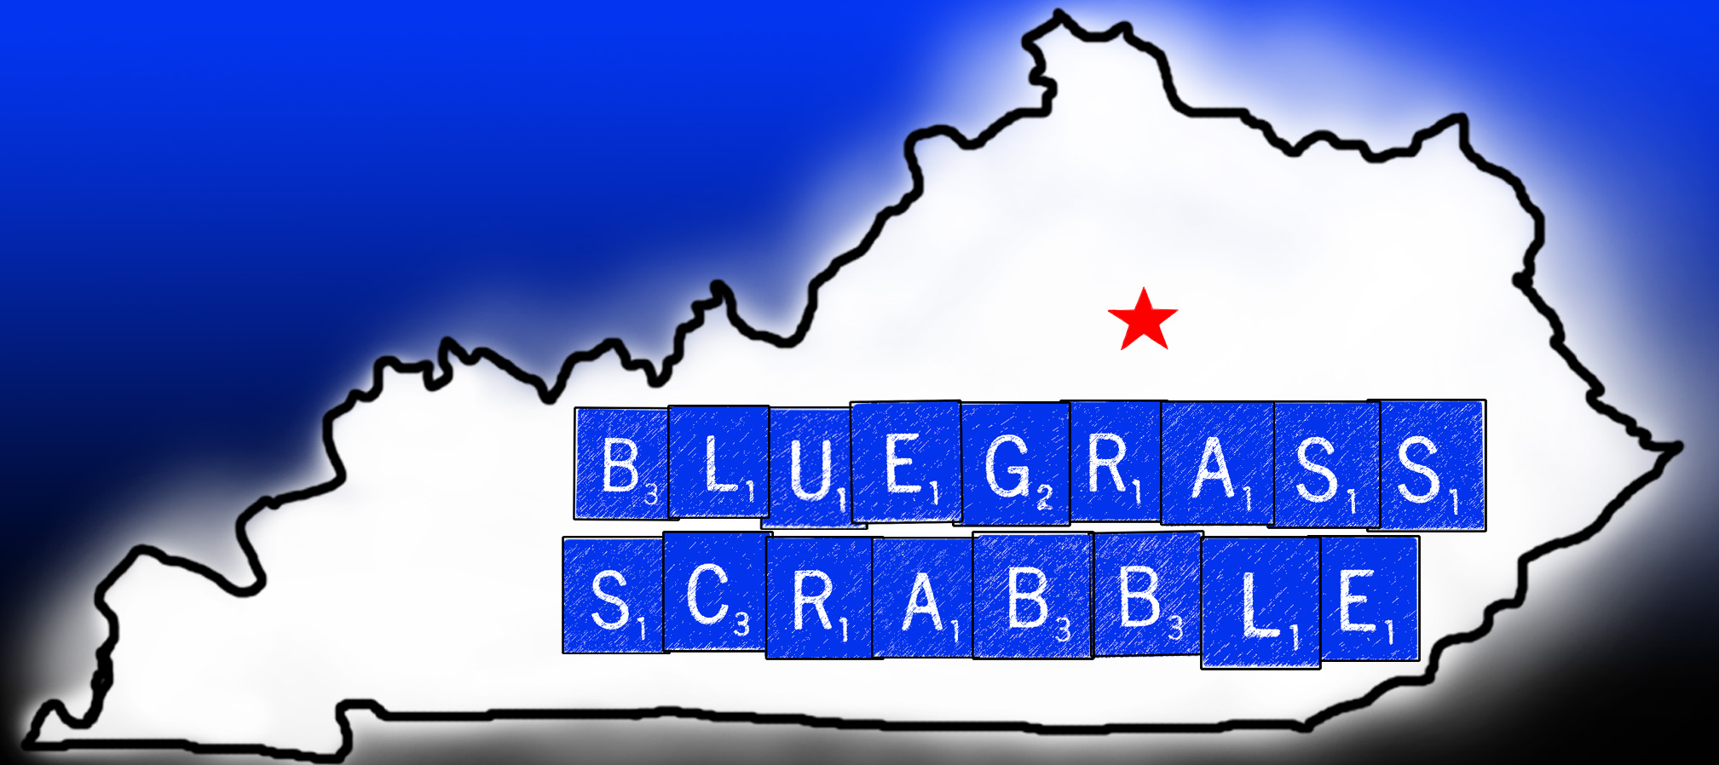
Bluegrass Spring Classic
NASPA-rated TWL Tournament
April 23, 2016
8 Games
Location: Meet on Main/Café Meeples (formerly Cosmic Oasis), 200 W. Main St., Richmond, KY 40475
This is the site of our club’s previous one-day tournaments. Downtown Richmond is minutes from Interstate 75,
about 25 miles south of Lexington. Special note: The owner has agreed to discount the room fee
(which the club will cover), so it’s strongly recommended that players buy lunch on site.
Here’s a link to the café: Cafemeeples.com.
After NASPA fees and Cross-Tables donation, return on entry fees will be close to 100 percent.

Director: Will Scott, rhubarbspiff@hotmail.com; 859-396-3162
Steve Bush, bush3262@yahoo.com

Registration 8:30 a.m.; games start at 9 a.m.

Entry Fee: $35 if received by April 20; $40 thereafter.
Divisions and pairings for all events subject to director’s discretion, depending on number/rating of entrants.

Registration:
Option 1:
Send entry fee(s) via PayPal to: bush3262@yahoo.com
Include email address and/or contact phone number, along with event(s) being played, in note.

Option 2:
Mail check with entry form on the following page.

©2015 Scrabble is a registered trademark of Hasbro, Inc.

Entry Form

Name: _____________________________________
Address: ___________________________________
City/State/Zip: ______________________________
Phone: ____________________________________
Email address: ______________________________
Total Enclosed: __________________
Mail check and entry form to:
Will Scott
250 Montgomery Ave.
Versailles, KY 40383

------------------------------------------------------------------------------------------

